
Food Safety Resources in Child Care Facilities

Updated February 2025
- VCH Environmental Health and Child Care Licensing
This website links to resources and services under the health protection including both Environmental Health and Facilities Licensing
- https://www.vch.ca/en/health-topics/health-protection-permits-and-licensing
- https://www.vch.ca/en/health-topics/child-care-facilities

- BC HealthLink Health Files
HealthLinkBC Health Topics are easy-to-understand information webpages that provide BC specific information. This link contains many relatable topics on healthy eating for children on food safety and preventing food borne illness.
- https://www.healthlinkbc.ca/healthy-eating-physical-activity/age-and-stage/infants-children-and-youth/healthy-eating-children
- https://www.healthlinkbc.ca/healthlinkbc-files/food-safety-child-care-facilities

This handout summarizes safety procedures in child care settings.
- https://www.healthlinkbc.ca/sites/default/files/documents/hfile59d.pdf

- Public Health Act, Food Premises Regulation
- http://www.bclaws.ca/civix/document/id/complete/statreg/210_99

- Caring About Food Safety; Simple Food Safety Course for Home Use
This is a free 1 hour online course on food safety.
- https://www2.gov.bc.ca/gov/content/health/keeping-bc-healthy-safe/food-safety/food-safety-courses

- FOODSAFE
The FOODSAFE Program is a comprehensive food safety training program.
- www.foodsafe.ca

- Food Safety for Children Ages 5 & Under
This is an easy-to-read brochure on basic food safety information.
- https://www.canada.ca/content/dam/hc-sc/migration/hc-sc/fn-an/alt_formats/pdf/securit/kitchen-cuisine/toolbox-boite-outils/fs-fr-children-enfant-eng.pdf

- BC Centre for Disease Control
This site contains a video called How to: Be Foodsafe
- http://www.bccdc.ca/health-info/prevention-public-health/food-safety

This site contains information on hand hygiene and handwashing posters
- http://www.bccdc.ca/health-info/prevention-public-health/hand-hygiene

- Government of Canada
This site contains information on CFIA food recall information.
- https://www.canada.ca/en/services/health/food-recalls-alerts.html

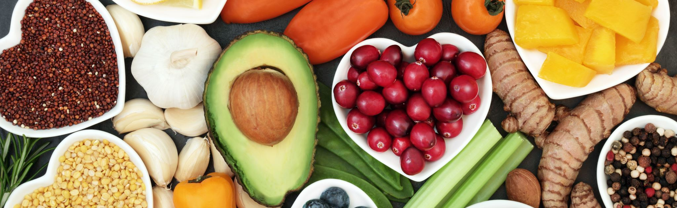
Nutrition Resources in Child Care Facilities Safe and Healthy Food

Updated February 2025
- Appetite to Play
Child Health BC supports early years providers, parents and caregivers to promote and encourage physical activity and healthy eating. This site includes a variety of training resources for early years providers to enhance their knowledge, skills and confidence in creating childcare settings that support healthy eating, physical activity, food and physical literacy.

- Public Health Dietitian Services | Vancouver Coastal Health
Public health dietitians collaborate with childcare facilities, health service providers, organizations, school districts, local governments and others to support policies, programs, resources and training to promote nutrition and health. health service providers, organizations, school districts, local governments and others to support policies, programs, resources and training to promote nutrition and health.

- Food Safety Resources | Vancouver Coastal Health
Environmental Health offers resources about food safety.

- HealthLinkBC | HealthLink BC
The Ministry of Health provides B.C. residents with reliable health information and services by internet or phone.

- BC School Food Toolkit - Building Healthy Inclusive School Food Environments
The Ministry of Health created the BC School Food Toolkit to support schools in creating and maintaining healthy school food environments with recipes, tips, videos, and more.

- Eating Healthy
First Nations Health Authority provides many resources related to healthy eating.

- Early Learning Framework - Province of British Columbia
B.C.’s Early Learning Framework guides early childhood educators, primary school teachers, principals and vice-principals, college and university educators and researchers, post-secondary students in early childhood and elementary education programs, other early years professionals, communities, governments and families.

- Canada's Food Guide
Canada's Food Guide website provides a suite of tools and resources on eating well.

- Healthy eating for parents and children - Canada's Food Guide
Health Canada provides specific guidance for parents and children on healthy eating.

- Healthy Eating and Food Safety
The BCCDC provides information about healthy eating, food literacy and food safety.

