No Food Operating Permit Required

CATEGORY 1 LOW RISK FOODS
(For Child Care Facilities)
Exempt from the health approval process by EHO
Requirements:
Child care licensees should ensure that proper care is taken in all food handling and sanitation to prevent causing a health hazard. Licensees must also promote healthy eating and nutritional habits.

Recommended Training Courses:
VCH Food Safety Short Course
OR
FOODSAFE Level 1 or its equivalent certification

Guiding Principles:
- Food is freshly prepared and eaten within 2 hours of preparation. No leftovers served or sent home with children.
- These foods require minimal ingredients and simple food handling. Refer to the Food Safety in Child Care Facilities for more information on safe food handling procedures. https://www.healthlinkbc.ca/sites/default/files/documents/hfile59d.pdf
- Children may serve themselves from a common plate using spoons or tongs but must eat from individual plates/bowls, not directly from the serving tray or bowl.
- Food prepared in permanent food service establishments (take out, caterers, restaurants etc) which is delivered, served and eaten within 2 hours is acceptable.
Food Examples
Use the brand name food list to help make choices when purchasing commercially prepared products. https://bnfl.healthlinkbc.ca/
These may be dispensed from larger containers to individual dishes/cups for immediate service and consumption – no additional preparation.
Examples
  - Canned and frozen unsweetened fruit
  - Canned unsweetened fruit sauces (e.g. applesauce)
  - Cooked apple/fruit sauce (prepared on site)
  - Dried fruit (commercially prepared or prepared on site)
  - Fruit and vegetable 100% juice (pasteurized)
  - Milk, soy beverages1
  - Hard cheese1, cheese strings1, yogurt1
  - Nuts, seeds, and seed and nut butters
  - Prepared condiments1 (e.g. pasteurized honey, jam, ketchup, mustard, butter, soft non-hydrogenated margarine, salad dressing, miracle whip, mayonnaise, etc)
  - Hummus1, salsa dips1 (dispense into small portions as required)
  - Roasted pumpkin seeds
  - Edamame cooked according to package instructions
  - Edamame salad (eg. Edamame, chopped red pepper, frozen corn and bottled dressing)
  - Homemade baked kale chips
  - Bean burritos3, cooked according to package directions.
Vegetables and Fruits
Most whole or sliced fresh fruits and vegetables may be prepared on site including garden produce grown on site (see Health File – Food Safety for Fresh Fruits and Vegetables). https://www.healthlinkbc.ca/sites/default/files/documents/hfile59d.pdf
Grain Products (No cream fillings)
  - Bread, buns, bagels, tortillas, (may be toasted)
  - Baked bannock, crackers
  - Pancakes (add water from pancake mix3)
  - Baking on site of low-hazard grain products (e.g. cookies, muffins, biscuits, bread, etc)
  - Products made in a bread machine
- Dry cereal (may serve immediately with 2% milk)
- Sandwiches made from nut butter/hard cheeses3/ and vegetables
Other
- Salad dressing from scratch using oil and vinegar but no protein (e.g. no mayonnaise) example recipe: oil, vinegar, mustard, sugar or pepper
  - Heating of breast milk or infant formula3
  - Catered foods from permitted premises
If you plan to offer traditional foods, foods for special occasions, or foods other than foods from Category 1, consult with your Licensing Officer.

Low Risk Foods

Recipes for Low Risk Foods in the Food Flair™ Early Years Practitioners Resource
Food Items | Page Number
Bagel Dippers | 152
Baked Bannock with Berries | 148
Banana Muffins | 158
Counting Fruit Salad | 131
Crock Pot Apple Sauce | 125
Crunchy Trail Mix | 147
Dip for Fruits | 127
Flat Bread | 150
Flatbread Dippers | 151
Fruit Kebab | 126
Instant Banana Pudding | 133
Oatmeal Cookies | 157
Roasted Pumpkin Seeds | 145
Squashy Muffins | 160
Sunomono Salad | 138
Tortilla Triangles | 153
Veggie Fruit Mini Muffins | 159
Yummy Yams | 143

Food Flair is a helpful resource for child care facilities full of activities, tips and recipes.
It is available on our website at https://www.vch.ca/en/media/29361
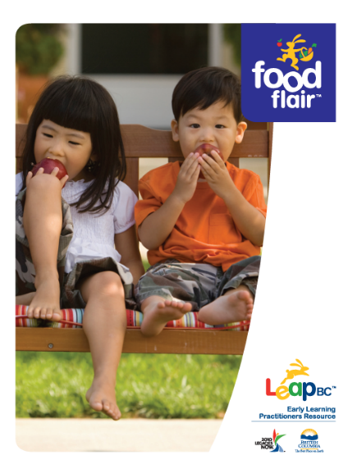


Commercially prepared products from approved sources.
Exclusions – these should not be served due to higher risk: (a) raw seed sprouts should not be served to children under age two; (b) honey should not be served to children less than one year of age.
Commercially prepared products from approved sources

