No Permit Required

CATEGORY 2 INCREASING RISK FOODS
(For Child Care Facilities)

FOOD
Consult with your local Licensing Officer if you plan to offer food from Category 2
Requirements:
Child care licensees should ensure that proper care is taken in all food handling and sanitation to prevent causing a health hazard. Licensees must also promote healthy eating and nutritional habits.

Recommended Training Courses:
VCH Food Safety Short Course
OR
FOODSAFE Level 1 or its equivalent certification

Guiding Principles:
- Food is freshly prepared and eaten within 2 hours of preparation. No leftovers served and should be discarded.
- These foods require minimal ingredients with some food handling and cooking permitted. Refer to the Food Safety in Child Care Facilities for more information on safe food handling procedures. https://www.healthlinkbc.ca/sites/default/files/documents/hfile59d.pdf
- Children may serve themselves from a common plate using spoons or tongs but must eat from individual plates/bowls, not directly from the serving tray or bowl.
- Food prepared in permitted food service establishments (i.e. restaurants and caterers) must be purchased, delivered and consumed within 2 hours.
Food Examples (and including all listed foods in Category 1):
- Cooked, fresh or frozen vegetables
- Commercially prepared canned beans/lentils
- Plain single grains (from dry) including oatmeal, rice, couscous, quinoa, barley, bulgur
- Cooked oatmeal (from scratch)
- Baked fries prepared on-site from whole yams/potatoes
- Whole baked potatoes (do not use foil to bake)
- Hard boiled eggs and sandwiches made from hard boiled eggs (no cracks)
- Vegetable soup
- Vegetarian pizza
- Hummus and bean dips (from scratch)
- Fresh salsa (no cooking)
- Green salad (vegetables only)
- Fruit salad
- Fruit and yogurt parfait
- Fruit smoothies
- Dips and dressings made from yogurt/sour cream/mayonnaise
- Pancakes made from scratch
Grilled cheese sandwiches

Increasing Risk Roods
Recipes for Increasing Risk Foods in the Food Flair™ Early Years Practitioners Resource
Food Items | Page Number
Apple Cheddar Quesadillas | 165
Black and Orange Salad | 137
Cool Berry Smoothies | 132
Dinosaur Dip | 139
Spinach Dip | 141
Egg Salad Crackers | 173
Fro-Yo on a Stick | 130
Fruit Pizza | 129
Fruit Yogurt Parfait | 128
Grate Salad | 136
Hummus Dip | 170
Japanese Rice Balls | 149
Oven Baked Potato Wedges | 142
Pumpkin Soup *using canned pumpkin & milk | 144
Salad in a Bag | 134
Vegetarian Participizza *no meat, fish, poultry or pasteurized soft cheeses | 163

Food Flair is a helpful resource for child care facilities full of activities, tips and recipes.
It is available on our website at https://www.vch.ca/en/media/29361
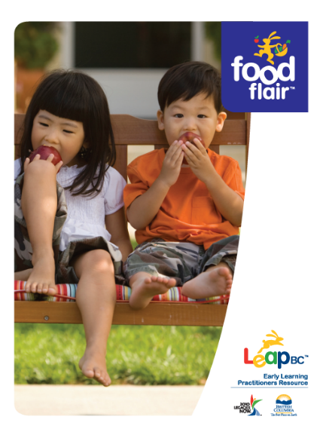


Prepared from pasteurized or commercially prepared products from approved sources – Operators should ensure that all juices are pasteurized and are kept refrigerated. Reference: HealthLink BC File #72 (https://www.healthlinkbc.ca/healthlinkbc-files/unpasteurized-fruitvegetable-juices-and-ciders-potential-health-risk)

